**Keragaan Kapilaritas Air di Tanah Gambut yang Diaplikasikan Membran SWRT pada Tutupan Lahan yang Berbeda**

*Capillary Action of Water on Peat Soil Applied SWRT Membranes in Different Land Uses*

**Muhammad Imam Nugraha**1), **Ahmad Kurnain**2)**\***

1)Program Studi Agroekoteknologi, Fakultas Pertanian, Universitas Lambung Mangkurat

2) Program Studi Ilmu Tanah, Fakultas Pertanian, Universitas Lambung Mangkurat

Jl. A. Yani Km 35.5, Banjarbaru, Kalimantan Selatan, 70714

**\***Korespondensi Penulis: [akurnain@ulm.ac.id](mailto:akurnain@ulm.ac.id)

Submisi: ……, *Review*: ……, Diterima (*Accepted)*: …..

***ABSTRACT***

*Plants, water, and peat soil interact to form peatland ecosystems, which are composed of these three interrelated elements. The water balance of peatlands is significantly influenced by the capillarity of the peat soil. This study attempts to ascertain the impact of depth on applying subsurface water retention technology (SWRT) membrane on capillary action based on moisture of peat soil in different land uses. A completely nested randomized design was utilized in this investigation to avoid bias of the different degree of decomposition between land uses. The type of land use—namely, shrubs (PL1) and agricultural land (PL2)—was the first account. The position of the membrane (its depth), which was set at -20 cm (D1), -30 cm (D2), and -50 cm (D3)* *and in addition to a control treatment without membrane installation (D0), was the second account.* *Three times each experimental unit was repeated. The YL-100 soil moisture content sensor, which is powered by Arduino, presented the research results. Arduino can produce digital values with a range of 0 to 1023 by converting moisture values that were output as analog signals into digital values using an analog to digital converter (ADC) with a resolution of 10 bits. The outcome revealed that soil moisture content increasing up to the peat soil layer of 5 to 10 cm until the fifth day of observation due to rainfall along our study that increased the flux of water flow into the peat soil.*

***Keywords****: capillary water, land use, membrane, peat soil, SWRT, soil moisture.*

© 2023 Nama Penulis

**INTRODUCTION**

Peatland is one form of swampland typology based on the nature and characteristics of the soil. Kalimantan Island has the second-largest area of peatland after Sumatra with 4.54 million ha or 33.8% of all the peatland in Indonesia. The smallest areas of peatlands are in the provinces of South Kalimantan and East Kalimantan with an area of 46,294 and 181,809 ha, respectively (Anda et al., 2021). The existence of peat soil layers with bulk densities less than 0.1 g cm-3 is one of the traits that distinguish peatlands apart from other types of land. Peat soil is a type of organic soil created by the accumulation of plant detritus and organic material that has only partially or not decomposed yet. Low nutritional status, high acidity (low pH), and some fragile physical attributes are certain characteristics of peat soils. The significant variation in rainfall has a significant impact on the composition of soluble organic matter in wet tropical peatlands (Bispo et al., 2016).

Capillary water in peatlands is essential for keeping the peat soil's top layer moist and supplying water to plants' roots when it enter the dry season. In the dry season, capillary movement could fail to reach the peat's topmost layer, which would render hydrophobic on peat soil. The inability of the surface of peat soil particles to retain water after drying is known as hydrophobicity. When the ratio of hydrophobic to hydrophilic components rises, hydrophobicity might result. According to research by (Nugraha et al., 2016), a peat water table of -80 cm marked the starting point of hydrophobicity, which was accompanied by a 7.25% increase in the ratio of hydrophobic groups. As shown by a reduction in the ratio of hydrophobic groups by 11.69%, peat soil with peat water table of -30 cm did not experience hydrophobicity.

The research also provided information about how the capillarity of peat soil water reduced at peat water table -80 cm, as indicated by the lowest water content in the upper layer of 37%. In contrast, peat soil capillary water at TMA -30 cm can reach the greatest value of water content in the surface layer to 308%. In peatlands, a quite-deep reduction of peat water table can interfere with the capillarity of soil water. In line with this, Kurnain (2019) shown that the maturity level of the peat has an impact on how much moisture is present in the acrotelm peat layer -the layer of soil that is permanently placed above the peat water table throughout the year.

Membrane technology for soil water retention, or so-called soil water retention technology (SWRT) as a solution to the issue of soil water availability has been widely proposed. Typical applications involve the addition of asphalt in the root zone (Hansen & Erickson, 1969), hydrophilic polymer gels (Silberbush et al., 1993), clay in the top layer of soil (Ismail & Ozawa, 2007), and the latest SWRT application is the implementation of impermeable polyethylene (PE) membranes in the root zone (Churchman & Landa, 2014).

The water use efficiency and eggplant production increased by 6% and 52%, respectively, as a result of Almasraf & Salim, (2018) research, which positioned the SWRT membrane at a depth of -35 cm in sandy loam soil. Additionally, irrigation water savings in SWRT membranes ranged from 44% instead of those in conventional membranes. Hommadi et al., (2021) the use of SWRT membranes on clay soil can cut water use by 7% and result in 15% higher okra yields than when no SWRT membranes were used.

The efficiency of membranes to enhance crop quality is the main focus of most recent researches on soil water retention, yet the membrane was never applied in peat soils which had distinctive characteristics and climate. Therefore, the objective of this study was to ascertain the impact of depth on applying a SWRT membrane on capillary action based on the moisture of peat soil in different land uses.

**MATERIAL AND METHODS**

**Material**

In the preliminary research, the character of the peat soil was measured to see the maturity of the peat soil used as a treatment. the study used the von Post methods to see the maturity of peat soil. Peat can be broken down into the following categories based on its level of maturity (Agus & Subiksa, 2008): (1) Sapric (highly decomposed) peat refers to peat that had undergone substantial weathering, the parent material is no longer discernible, dark brown to black in color, and when squeezed off, the fiber content is only 15% (2) Hemic peat (moderately decomposed) was semi-rotted peat, brown in color, had a fiber content of 15–75% when squeezed off, and still contains some discernible parent material. (3) Fibric (raw) peat had not yet weathered, was still recognizably the original material, brown in color, and when the peat soils were squeezed off >75% of the fiber remains still.

The other main research material was an impermeable polyethylene membrane. This type of membrane was commonly used as a surface of coating material so that water did not pass it through, for example, it was used as a surface coating for the bottom of water reservoirs and water storage, or water ponds for fish farming. The type of membrane used in this research is HDPE (high density polyethylene) with a thickness ranging from 0.3-0.5 mm. The tools used in this research include an Arduino Uno R3 moisture probe and supporting equipment such as: knives/spoons, markers, plastic bags; label paper, cloth, and GPS (Global Positioning System).

Soil moisture was measured at voltage resolution using the soil moisture sensor YL-100, supported by Arduino as a microcontroller. This circuit board or IC (integrated circuit) features a 16 MHz ceramic resonator, a USB port, a power plug, an ICSP header, a reset button, and 14 digital input/output (I/O) with the digits 0 to 13. It also has six analog input pins with the symbols A0 to A5. The Analog to Digital Converter (ADC) function of the ATmega328 microcontroller allows analog signals to be transformed into digital values. The 10-bit resolution of this microcontroller allows for a total of 1024 (210) potential click values. In other words, this Arduino can translate input voltages between 0 V and operating voltage (5 V or 3.3 V) into integer values between 0 and 1023. To express soil moisture, These ADC reading were translated back to voltage following based on equation of (Bengtsson, 2013).

$U=\frac{∆}{2^{n}}x1000$………… (1)

Description:

U = Soil moisture’s voltage (mV)

Δ = ADC reading or integer value (0-1023)

n = bit of resolution on Arduino

**Research Procedure**

The research was conducted in peatland, located on Landasan Ulin Utara Village, Subdistrict of Banjarbaru Utara, Banjarbaru City, South Kalimantan (-3° 24' 43.7826"; 114° 43' 14.3538"). The experiment had been conducted for three months, starting from August to October 2020. Two different land uses, shrubs (PL1) and agricultural land (PL2), were chosen for this study's treatment. PL1 had a hemic degree because when it was squeezed off, its fiber content was 50% and it was brown in color, but PL2 had a sapric degree since its fiber content was only 10% and it was black in color. For each type of land use, experimental plots measuring 150 cm long by 120 cm wide were created. The membrane is installed in the soil of experimental plots at a depth according to the treatment. The soils that had been installed with the membrane was allowed to stand for one month to allow the soil to recover. Furthermore, moistures of peat soils were carried out for 11 days using an Arduino Uno R3 moisture probe at every 5 cm interval of soil depth up to 20 cm.

**Experimental Design**

This study used a completely nested randomized design to prevent bias from different degrees of decomposition between land uses. The first factor was the type of land use, namely: shrubs (PL1) and agricultural land (PL2). The second factor was the location (depth) of the membrane, which was placed at the depth of the peat layer, namely: -20 cm (D1), -30 cm (D2), and -50 cm (D3) plus a control treatment without membrane installation (D0). Each experimental unit was repeated 3 (three) times.

**Analysis data**

An analysis of the data was done with the water content of peat soils as the primary parameter. The Least Significant Difference (LSD) test was conducted with a significant level (α) of 5% after the analysis of variance. STAR (Statistical Tool for Agricultural Research) software was used to conduct the statistical analysis for this study.

**RESULTS AND DISCUSSION**

**Distribution of Peat Soil Moisture on Depth of 0-20 cm**

The distribution of peat soil moisture is the utmost importance for hydrological regulation because they are regulating the dynamics of nutrients on peatland ecosystems. In this research, the moisture of peat soil measured every 5 cm and presented down to -20 cm below the surface.

The results indicated that mostly on the observation day-4th to 7th, there was a high dynamics distribution of moisture in peat soil. Soil moisture was distributed due to water movement in the pores of the peat soil. The total porosity of peat soils consists of both fairly large, between-particle pores that could actively convey water and largely remain closed, and impassable pores constructed from plant cell remnants obtained from plant detritus (Hayward & Clymo, 1982; Kremer et al., 2004). Peat was shown to have permeable and interconnected macropores, enclosed or closed to some degree of pores, and impassable or discrete pore spaces using scanning electron microscopy (SEM). The dual-porosity phenomenon seen in macroscopic peat sample scales was caused by these micro-scale pore structures. One sort of porosity is called mobile porosity, and the other was called immobile porosity since it contains immobile water portion (Hoag & Price, 1997; Rezanezhad et al., 2012; Rezanezhad et al., 2017).

The arrangement of peat soil pores was highly differentiated by the level of decomposition of peat soils. In this research, we found that peat soils that had undergone agricultural land uses over seven

years (PL1) had a high level of decomposition, or sapric peat. Meanwhile, the peat soils that has recently experiences openness and has shrubs as they cover (PL2) had a moderate level of decomposition. These level of decomposition of peat soils took charge on the gradient of distribution of moisture that exhibited PL1 in sapric level tended to have higher dynamic distribution of peat soils whereas the PL2 in moderate level of decomposition (hemic condition) had more moderate distribution of moisture (**Figure 1** and **Figure 2**). The properties of peat soils from from surface down to the 40–45 cm layer varied significantly depending on the type of land used. That differing results consequently triggered variation level of decomposition had been caused by changes in drainage and vegetation cover (Könönen et al., 2015)

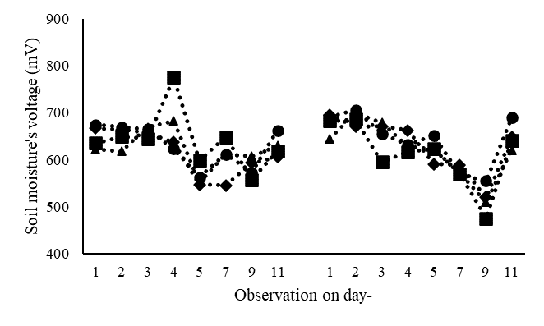

Shrubs (PL1)

Agricultural land (PL2)

**(a)\***

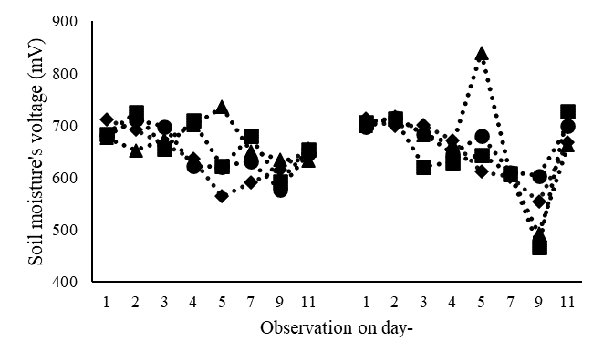

Shrubs (PL1)

Agricultural land (PL2)

**(b)\***

Note: Soil moisture at 0-5 cm (a) and 5-10 cm (b); Membrane treatment D-0 (●), D-20 (■), D-30 (▲) and D-50 (♦)

**Figure 1**. The distribution of moisture in peat soil at 0-10 cm

Differentiation of distribution on moisture of peat soils was also mentioned on some previous researches. In the temperate climate region, the most decomposed peat samples release less than 10% of their water to drainage, whereas undecomposed peat with high fiber content and a high active porosity loses up to 80% of its saturated water content to drainage (Letts et al., 2000). Similar to temperate region, Kurnain (2015) also confirmed that tropical peat soils that are more compacted, have lesser total porosity, are highly decomposed, and comprise more micro-pores. The water also will be held in place by the micro-pores more firmly and release at a slower rate as a result. Compared to the subsurface layer of peat soils (50-100 cm), the distribution moisture of peat soils in surface layer (0-50 cm) is more dynamic and the higher level of decomposition of peat soil which had more micro-pores tend to release water slower than peat soils with the lower level of decomposition (Indahyani et al., 2017; Sajarwan et al., 2021).

The SWRT membranes are beneficial for peat soil capillarity as well. In order to assess the capillarity in the present study, SWRT membranes have been installed in accordance with the peat water table from previous research. Peat soil moisture could reach the surface if the peat water table was 40 cm below the surface (Peraturan Pemerintah RI, 2016). Previous research states that peat soil moisture on the surface was still maintained if the peat water table was 50 cm below the surface (Nugraha et al., 2016).

**Figure 2.** The distribution of moisture in peat soil at 10-20 cm

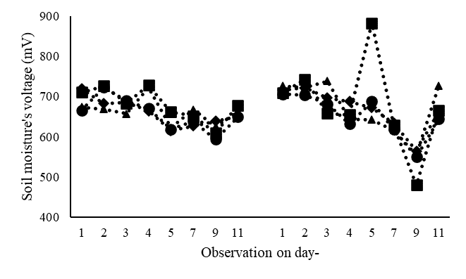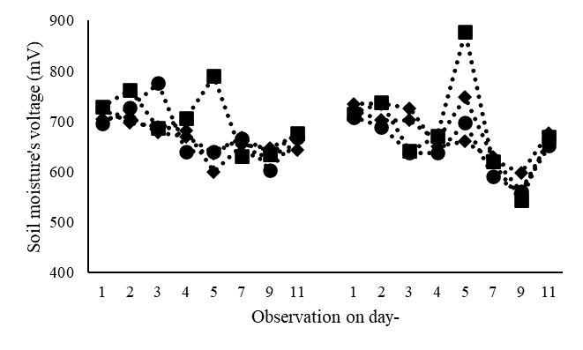

Note: Soil moisture at 10-15 cm (c) and 15-20 cm (d); Membrane treatment D-0 (●), D-20 (■), D-30 (▲) and D-50 (♦)

Shrubs (PL1)

Agricultural land (PL2)

(c)*

Shrubs (PL1)

Agricultural land (PL2)

(d)*

The findings demonstrated that in both PL1 and PL2 treatments, membranes put 20 cm (D-20 cm) and 30 cm (D-30 cm) below the surface were effective at preserving the moisture content of peat soil. Rainfall was able to be retained below the surface by the SWRT membrane, which served as an artificial peat water table in this research, allowing it to rise to the surface in a capillary action. The natural water table in peatlands fluctuated depending heavily on variations in rainfall (Wakhid & Zainudin, 2019). Apart from rainfall impact, alteration in the physical and chemical characteristics of the peat soil itself had an impact on water availability in peat soils as well (Könönen et al., 2015). These membranes markedly raised the volumetric water content in plant root zones, enhancing agricultural yield and water usage efficiency. The membrane boosted cucumber and green bell pepper yields by 20% and 24%, respectively, while also increasing volumetric water content to 15% and 18% simultaneously (Smucker et al., 2018).

This study represented soil moisture’s voltage resolution data. A soil's natural electric field (electric potential), resistance (conductivity), electroosmosis, and dielectric constant were examples of physical and electrical characteristics of soils. Each component of soil (solids, liquids and gases) possessed a distinct capacity to hold electrical charge, known as its dielectric constant. While the dielectric of each of these varies, they all generally had low dielectric properties when compared to water. We might therefore relate the volumetric water content to the fact that the only other substances that significantly influenced the soil's ability to store charges when the dielectric sensor measured them were water and air. Dielectric constant and conductivity are independent in theory. However, in reality, diffuse transport and electrode polarization commonly interact with one another, particularly in composites, especially soil in this subject, where there is also interfacial polarization at the matrix contact. Due to an increase in ion conduction-related polarization, the value of the dielectric constants has increased as well (Ahamad & Varma, 2010). Therefore, by figuring out the dielectric constant, the goal of monitoring the soil moisture could be achieved (Prasasti et al., 2012; Yu et al., 2021).

Similar mechanisms, such as porosity and tortuosity occurring in the identical pore structures, drive the flow of both electrical current and water in porous media. It was useful to use soil electrical conductivity measurements to forecast hydraulic conductivity in unsaturated soils because soil electrical conductivity was easily measured. Prior studies employed a simplified methodology that simultaneously measured electrical conductivity and water content. Due to the inclusion of effective porosity or tortuosity factors in the electrical conductivity, the determination of the hydrodynamic parameters of soil samples can be done more quickly than using the Mualem-van Genuchten model (Doussan & Ruy, 2009; Mualem, 1976). Even the other previous research Niu et al. (2015) with their electrical conductivity model had a smaller error rate of results with a root mean square deviation (RMSD) value of 0.28 compared to the Mualem-van Genuchten model which had RMSD value of 0.97.

In this study, there was no significant effect of the moisture content of the membrane-treated soil to the soil without the membrane. It was suspected that there were still many environmental factors that influenced the treatment during the study. One of them was the source of water input that is still high from the rain that continues to occur for five days from the first day of the study and another factor was the high groundwater level so that soil moisture even though the membrane was not installed would still be maintained until the surface of the soils.

**CONSCLUSION**

The results showed soil moisture content increased up to the peat soil layer of 5 to 10 cm until the fifth day of observation that due to rainfall over the course of our study, which increased the flux of water flow into the peat soil. Peat soils near the surface that are in frequent touch with the top environment have greater resilience due to interaction of membrane depth and land use type, which could make them more susceptible to quick oxidation if not effectively managed by proper technology.

**ACKNOWLEDGMENTS**

The authors immensely appreciated the cooperation provided by the Lambung Mangkurat University Principal in generating funding resources in the University's 2020 budget execution list. They obtained funding for the study in 2020 from Lambung Mangkurat University under the *Program Dosen Wajib Meneliti*.

**REFERENCES**

Agus, F. and I. M Subiksa,. 2008. Lahan Gambut: Potensi untuk Pertanian dan Aspek Lingkungan. *Balai Penelitian Tanah. Badan Penelitian dan Pengembangan Pertanian*. http://www.icraf.cgiar.org/sea

Ahamad, M.N. and K.B.R. Varma,. 2010. Dielectric properties of (100−x)Li2B4O7–x(Ba5Li2Ti2Nb8O30) glasses and glass nanocrystal composites. *Materials Science & Engineering B*. 167(3). 193–201. https://doi.org/10.1016 /j.mseb.2010.02.016

Almasraf, S.A. and A.H. Salim. 2018. Improvement of the Water Use Efficiency and Yield of Eggplant by Using Subsurface Water Retention Technology. *Journal of Engineering*. 24(3). 152–160. https://doi.org/10.31026/j.eng.2018.03.12

Anda, M., S. Ritung, E. Suryani, Sukarman, M. Hikmat, E. Yatno, A. Mulyani, R.E. Subandiono, Suratman and Husnain. 2021. Revisiting tropical peatlands in Indonesia: Semi-detailed mapping, extent and depth distribution assessment. *Geoderma*. 402(7). 115235. https:// doi.org/10.1016/j.geoderma.2021.115235

Bengtsson, L.E. 2013. Interpolation of microcontroller ADC by self-induced dithering. *International Journal on Smart Sensing and Intelligent Systems*. 6(4). 1366–1382. https://doi.org/10.21307/ijss is-2017-594

Bispo, D. F. A., A. C. Silva, C. Christofaro, M.L.N. Silva, M.S. Barbosa, B. P. C. Silva, U. M. Barral and J. D. Fabris. 2016. Hydrology and carbon dynamics of tropical peatlands from Southeast Brazil. *CATENA*. 143. 18–25. https:// doi.org/10.1016/j.catena.2016.03.040

Churchman, G. J. and E.R. Landa. 2014. The soil underfoot: Infinite possibilities for a finite resource. *The Soil Underfoot: Infinite Possibilities for a Finite Resource*. https://doi.org/10.1201/b16856

Doussan, C., and S. Ruy. 2009. Prediction of unsaturated soil hydraulic conductivity with electrical conductivity. *Water Resources Research*. 45(10). 1–12. https://doi.org/10.1029/2008WR007309

Hansen, C.M. and A.E. Erickson. 1969. Use of Asphalt to increase Water Holding Capacity of Droughty Sand Soils. *Industrial & Engineering Chemistry Product Research and Development*. 8(3). 256–259.

Hayward, P. M. and R.S. Clymo. 1982. Profiles of water content and pore size in Sphagnum and peat, and their relation to peat bog ecology. *Proceedings of the Royal Society of London - Biological Sciences*. 215(1200). 299–325. https://doi.org/10.1098/rspb.1982.0044

Hoag, R.S. and J.S. Price. 1997. The effects of matrix diffusion on solute transport and retardation in undisturbed peat in laboratory columns. *Journal of Contaminant Hydrology*. 28(3). 193–205. https://doi.org/10.1016/S0169-7722(96)0 0085-X

Hommadi, A.H., F.M. Al-Mohammed, A. K. A. Mutasher, A.I Al Obaidy, S.S. AL-Rawi, S.A. Almasraf and A.M Alfawzy. 2021. Application of SWRT Technique to Reduce Stress and Water supply. IOP Conference Series: Earth and Environmental Science. 722. 012044. https://doi.org/10.1088/1755-1315/722/1/ 012044

Indahyani, S., Sumawinata, B., and D. Darmawan. 2017. Pengukuran Retensi Air Tanah Gambut Menggunakan Kombinasi Three Phase Meter dan Ceramic Plate. *Buletin Tanah Dan Lahan*. 1(1). 109–114.

Ismail, S. M. and K. Ozawa. 2007. Improvement of crop yield, soil moisture distribution and water use efficiency in sandy soils by clay application. *Applied Clay Science.* 37(1–2). 81–89. https://doi.org/10.1016/ j.clay.2006.12.005

Könönen, M., J. Jauhiainen, R. Laiho, K. Kusin and H. Vasander. 2015. Physical and chemical properties of tropical peat under stabilised land uses. *Mires and Peat*. 16. 1–13.

Kremer, C., F. Pettolino, A. Bacic and A. Drinnan. 2004. Distribution of cell wall components in Sphagnum hyaline cells and in liverwort and hornwort elaters. *Planta*, 219(6). 1023–1035. https://doi. org/10.1007/s00425-004-1308-4

Kurnain, A. 2015. Moisture Release of Tropical Peat Soils As Decreasing Water Table. *Tropical Wetland Journal*. 1(1). 33–37. https://doi.org/10.20527/twj.v1i1. 15

Kurnain, A. 2019. Hydrophysical properties of ombrotrophic peat under drained peatlands. *International Agrophysics*. 33(3). 277–283. https://doi.org/10.31545/ intagr/110773

Letts, M. G., N.T. Comer, N.T. Roulet, M.R. Skarupa and D.L. Verseghy. 2000. Parametrization of peatland hydraulic properties for the Canadian land surface scheme. *Atmosphere - Ocean*. 38(1). 141–160. https://doi.org/10.1080/07055900. 2000.9649643

Mualem, Y. 1976. A new model for predicting the hydraulic conduc. *Water Resources Research*. 12(3). 513–522.

Niu, Q., D. Fratta and Y.H. Wang. 2015. The use of electrical conductivity measurements in the prediction of hydraulic conductivity of unsaturated soils. *Journal of Hydrology*. 522. 475–487. https://doi.org/10.1016/j.jhydrol. 2014.12.055

Nugraha, M. I., W. Annisa, L. Syaufina and S. Anwar. 2016. Capillary Water Rise in Peat Soil as Affected by Various Groundwater Levels. *Indonesian Journal of Agricultural Science*. 17(2). 75. https://doi.org/10.21082/ijas.v17n2.2016.p75-83

Peraturan Pemerintah Republik Indonesia. 2016. Peraturan Pemerintah No. 57 Tahun 2016 tentang Perubahan Atas Peraturan Pemerintah No. 71 Tahun 2014 tentang Perlindungan dan Pengelolaan Ekosistem Gambut. *Kementrian Hukum dan Hak Asasi Manusia*.

Prasasti, I., I. Carolita, A.E. Ramdani, dan I. Risdiyanto. Pemanfaatan Penginderaan Jauh, P., & Geofisika dan Meteorologi, J. 2012. Kajian Pemanfaatan Data Alospalsardalam Pemetaan Kelembaban Tanah (the Study of Alos Palsar Data Application for Soil Moisture Estimation). *Jurnal Penginderaan Jauh.* 9(2). 102–113.

Rezanezhad, F., R. Andersen, R. Pouliot, J.S Price, L. Rochefort and M.D. Graf. 2012. How fen vegetation structure affects the transport of oil sands process-affected waters. *Wetlands.* 32(3). 557–570. https://doi.org/10.1007/s13157-012-0290-z

Rezanezhad, Fereidoun, C. Kleimeier, T. Milojevic, H. Liu, T.K.D. Weber, P. Van Cappellen and B. Lennartz. 2017. The Role of Pore Structure on Nitrate Reduction in Peat Soil: A Physical Characterization of Pore Distribution and Solute Transport. *Wetlands*. 37(5). 951–960. https://doi.org/10.1007/s13157-017-0930-4

Sajarwan, A., A. Jaya and I.S Banuwa. 2021. Water Retention and Saturation Degree of Peat Soil in Sebangau Catchment Area, Central Kalimantan. *Journal of Tropical Soils*. 26(1). 29. https://doi.org/10.5400/ jts.2021.v26i1.29-42

Silberbush, M., E. Adar and Y. De Malach. 1993. Use of an hydrophilic polymer to improve water storage and availability to crops grown in sand dunes I. Corn irrigated by trickling. *Agricultural Water Management*. 23(4). 303–313. https:// doi.org/10.1016/0378-3774(93)90042-9

Smucker, A. J., Levene, B. C. and M. Ngouajio, M. 2018. Increasing Vegetable Production on Transformed Sand to Retain Twice the Soil Water Holding Capacity in Plant Root Zone. *Journal of Horticulture.* 05(04). https://doi.org/10.4172/2376-0354.1000246

Wakhid, N. and Zainudin. 2019. Pemantauan Dinamika Tinggi Muka Air Secara Otomatis Di Lahan Gambut. *EnviroScienteae*. 15(3). 374. https:// doi.org/10.20527/es.v15i3.7430

Yu, L., W. Gao, R.R. Shamshiri, S. Tao, Y. Ren, Y. Zhang, and G. Su. 2021. Review of research progress on soil moisture sensor technology. *International Journal of Agricultural and Biological Engineering*. 14(4). 32–42. https://doi.org/10.25165/ j.ijabe.20211404.6404